**MANUAL QA**

***Homework - Lesson 9***

**Student Name:** Mario Lima

***Level 1:***

***Make a comparison of static and dynamic testing techniques. Give the advantages and possible limitations when using each of them.***

|  | **Static testing technique** | **Dynamic testing technique** |
| --- | --- | --- |
| **Advantage 1** | Can detect issues earlier in the development process. | Can find defects that cannot be identified through static testing. |
| **Advantage 2** | Can be performed without running the code, which saves time and resources. | Can validate system functionality and behavior. |
| **Advantage 3** | Can be done manually or with the help of automated tools. | Can be automated, which saves time and effort. |
| **Limitation 1** | May not catch all defects and issues. | May not find all defects or issues. |
| **Limitation 2** | May require more time and effort than dynamic testing. | May not be suitable for certain types of applications or systems. |
| **Limitation 3** | May not be suitable for complex systems or projects. | Can be difficult to reproduce certain scenarios or user behaviors. |

***Level 2:***

***1. Complete the tasks of the previous level.***

***2. The following statement is about decision coverage:***

***When the code has a single 'IF' condition and no loops (LOOP) or switches (CASE), any test we run will result in 50% decision coverage.***

***Which option is true about this statement?***

a) Correct. Any test case provides 100% coverage of statements, thus covering 50% of solutions.

b) Correct. The result of any IF condition test will be either true or false.

c) Incorrect. A single test case can guarantee 25% coverage of the solutions in this case.

d) Incorrect, because it is too general a statement. We cannot know if it is correct as it depends on the software being tested.

***3. There’s the following pseudocode: Switch PC on -> Start MS Word -> IF MS Word starts THEN -> Write a poem -> Close MS Word.***

***How many test cases will it take to test its functionality?***

a. 1 for operator coverage, 2 for decision coverage

b. 1 for operator coverage, 1 for decision coverage

c. 2 for operator coverage, 2 for decision coverage

d. 2 for operator coverage, 1 for decision coverage

***4.*** ***How many tests are needed to check code statements:***

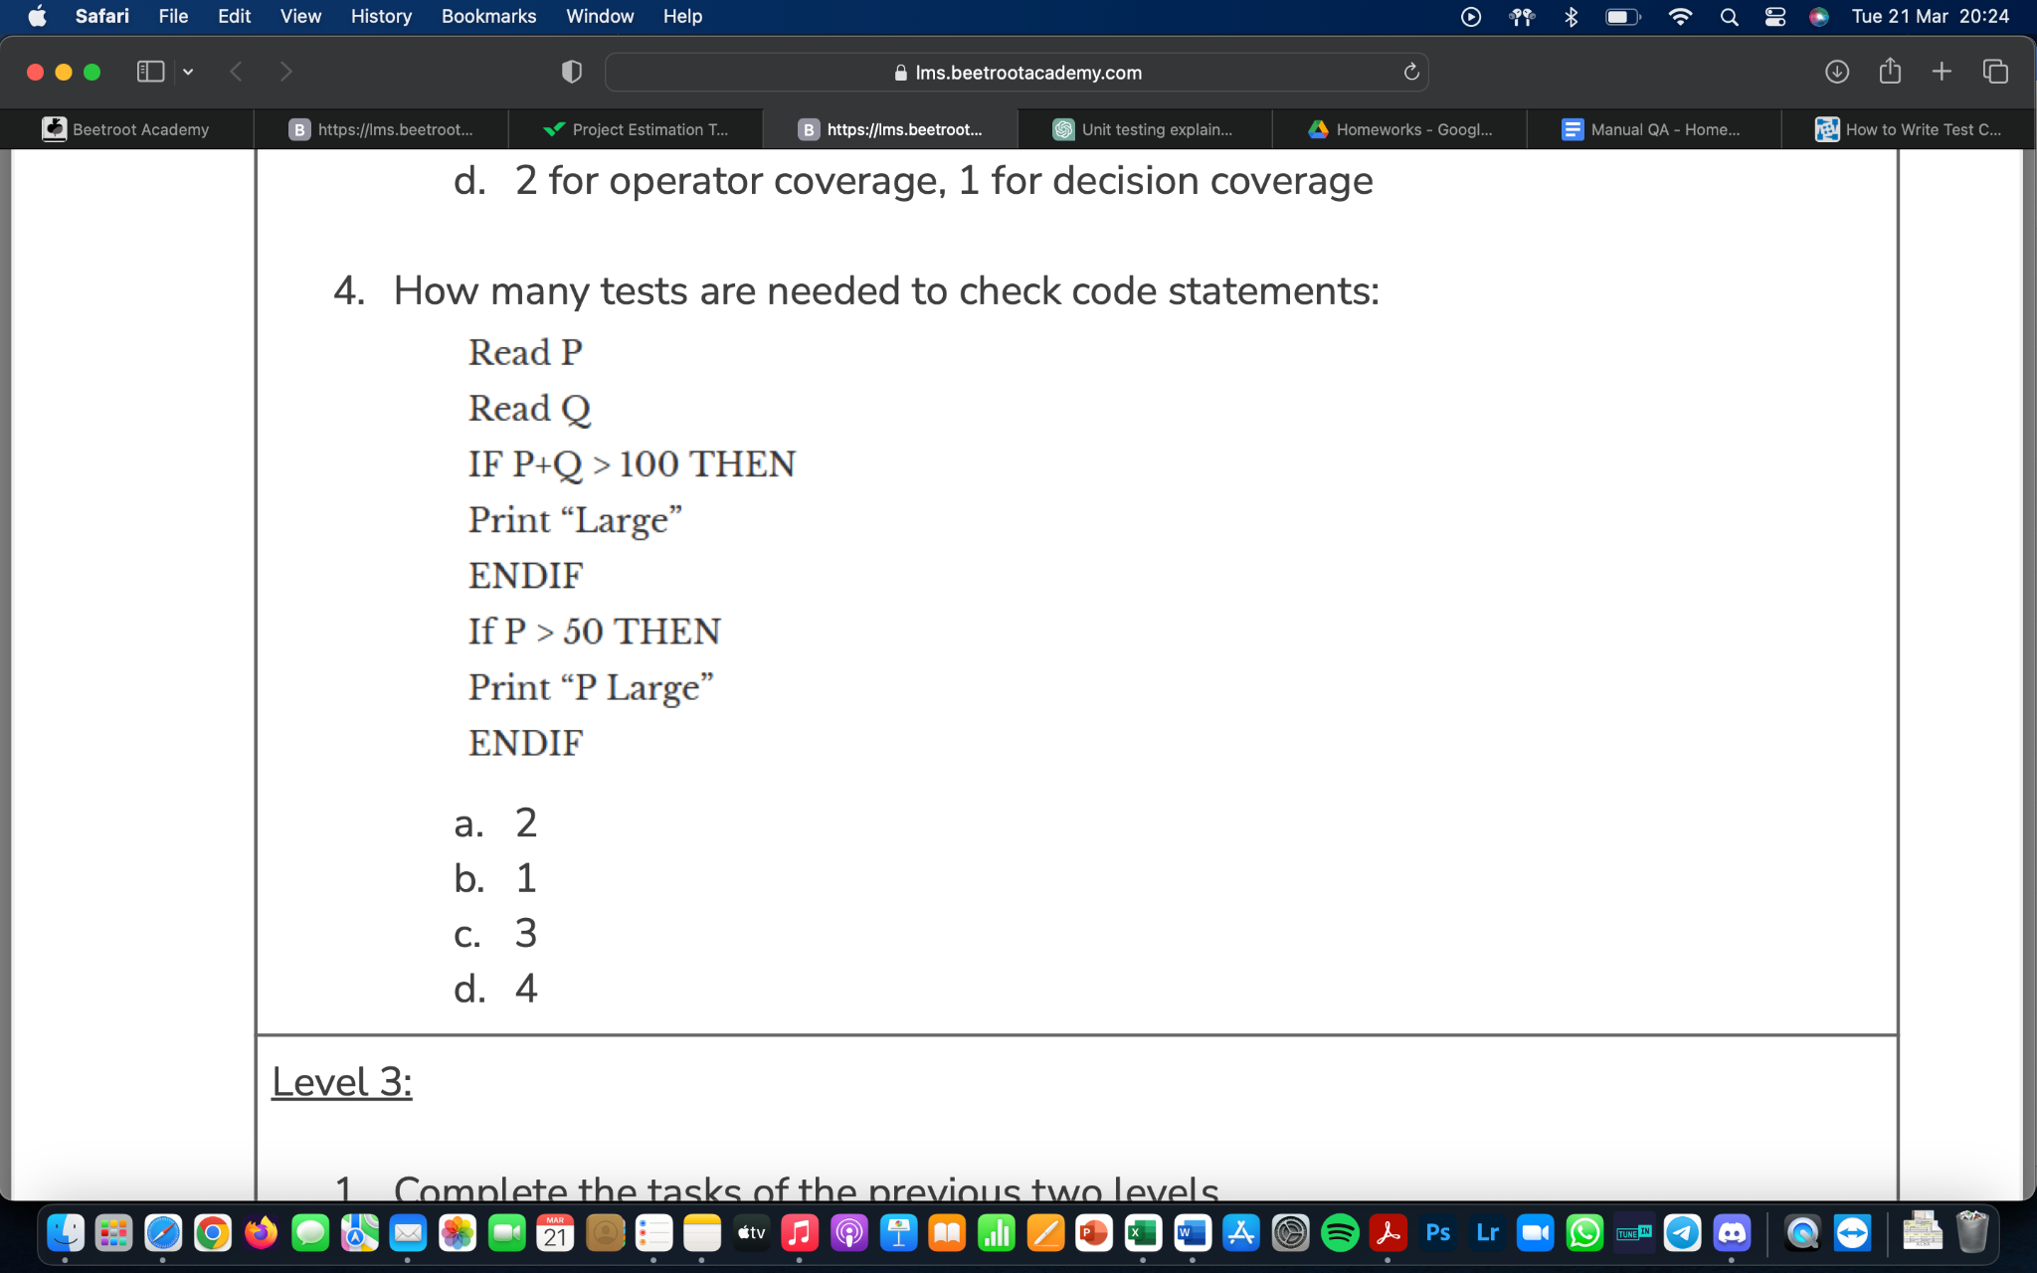

a. 2

b. 1

c. 3

d. 4

***Level 3:***

***1.*** ***Complete the tasks of the previous two levels.***

***2.*** ***We continue working on a startup for a cat photo sharing app.***

*There’s the following algorithm:*

*Ask what kind of pet the user has. If the user answers that they have a cat, then ask what breed it is: "short-haired or long-haired?" If the user answers "long-haired", then ask: "Would you like to get the contacts of the nearest groomer?" If the user answers "yes", then say: "Give me the address of the nearest cat grooming salon."*

*else Say: "Suggest a shop with fur care products" end else Say "Suggest a pet shop"*

*end*

*If the user has no cat*

*Say "Come back when you decide to get a cat"*

*end*

***Assignment:***

***1. Draw an algorithm diagram (in a tool of your choice, for example, in the built-in Google Docs editor, figjam, or other.)***

**Diagram in the link:**

<https://drive.google.com/file/d/1KSbrRLtu0rcKXT6y1dMdw5z27HL-zFsX/view?usp=sharing>

***2. What is the minimum set of test cases needed to make sure that all questions have been asked, all combinations have been passed, and all answers have been obtained?***

6 test cases for decision coverage and 4 test cases for statement coverage